ITLHOKOMELENG WEBSITE PROJECT
1. Selected Organisation
The organisation selected for this website development project is Itlhokomeleng Association for the Aged and Disabled, a community-based organisation located in Alexandra, Johannesburg, Gauteng. Itlhokomeleng provides care and support to elderly, frail, disabled and vulnerable people in the community.
The organisation was founded in 1978 by Dr Marjorie Manganye after she identified the need to assist elderly people who had no one to care for them. The organisation was formally registered as a welfare organisation in 1984. In 1991, a permanent facility was established, including a frail-care unit.
The organisation has continued to support vulnerable people in Alexandra. Public sources have reported that Itlhokomeleng provides care to more than 100 elderly and disabled individuals and has also operated an outreach programme to support people outside the association.
2. Research and Planning
2.1 Website Project Proposal
1. Organisation Overview
Name of organisation:
Itlhokomeleng Association for the Aged and Disabled
Location:
141 8th Avenue, Alexandra, Gauteng, South Africa.
History
Itlhokomeleng was established in 1978 by Dr Marjorie Manganye. The organisation began as a community initiative intended to assist elderly people who were vulnerable, neglected or without adequate family support. The organisation was subsequently registered as a welfare organisation in 1984. A permanent home, including a frail-care unit, was established in 1991 with support from organisations including the Sandton Rotary Club and Anglo-American. Itlhokomeleng has developed into an important community organisation in Alexandra, providing care to elderly and disabled people. The organisation has also received support from businesses, community organisations and charitable initiatives.
Mission
To provide compassionate care, support and dignity to elderly, disabled and vulnerable members of the community while promoting their wellbeing and inclusion.
Vision
To create a caring and inclusive community where elderly and disabled people are valued, supported and able to live with dignity.
Target Audience
The target audience for the website includes:
- Elderly and disabled people and their families
- Caregivers
- Community members
- Volunteers
- Potential donors and sponsors
- Businesses interested in corporate social investment
- Community organisations
- Government and social development stakeholders
- Members of the general public
2. Website Goals and Objectives
The primary goal of the website is to create a professional and accessible online presence for Itlhokomeleng.
The website objectives are to:
- Provide visitors with reliable information about Itlhokomeleng.
- Explain the organisation's history and purpose.
- Present information about its services and care programmes.
- Encourage members of the public to volunteer.
- Encourage businesses and individuals to provide sponsorship and donations.
- Make contact information easy to find.
- Provide an online enquiry form.
- Improve awareness of the organisation and its work in Alexandra.
- Create a trustworthy and professional digital identity for the organisation.
2.1 Key Performance Indicators (KPIs)
The success of the website can be measured using:
KPI | Measurement
Website visitors | Number of visitors per month
Page views | Number of pages viewed
Enquiries | Number of enquiries received
Volunteer enquiries | Number of volunteer submissions
Sponsorship enquiries | Number of sponsorship enquiries
Contact form submissions | Number of completed forms
Website engagement | Average time spent on website
Mobile accessibility | Website performance on mobile devices
Navigation success | Percentage of users able to locate important inform

3. Current Website Analysis
Research indicates that Itlhokomeleng has a limited digital presence compared with larger non-profit organisations. Information about the organisation is available through third-party sources, news articles and community-related publications rather than through a comprehensive official website.
For example, SABC News published information about the organisation's history, location, leadership and work with elderly and disabled people.
Other publications have highlighted the organisation's community activities, including support for elderly people, food assistance, donations and outreach activities.
This creates an opportunity for the proposed website to bring important information together in one central location.
The new website should therefore focus on:
- Clear navigation
- Accurate organisational information
- Accessible contact details
- Volunteer opportunities
- Sponsorship opportunities
- Services and programmes
- Community impact
- Professional presentation
- Mobile responsiveness
4. Proposed Website Features and Functionality
The website will contain a minimum of five pages.
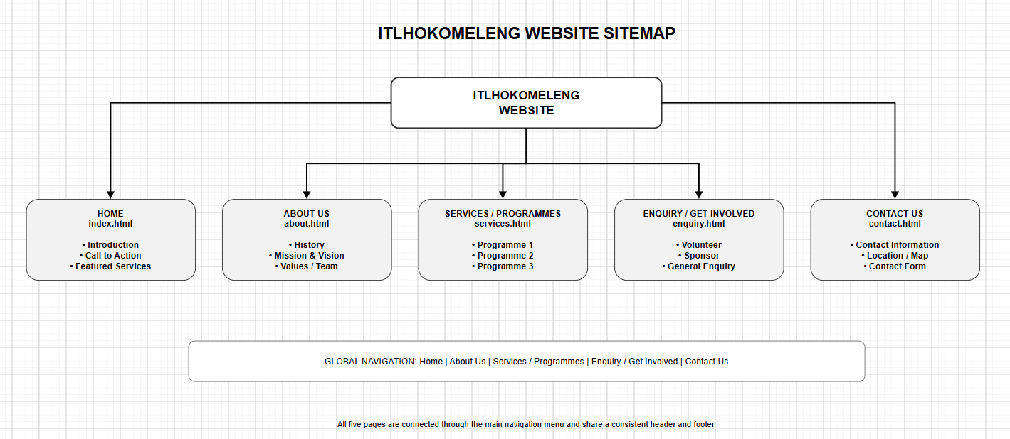
4.1 Home Page – index.html
The home page will introduce Itlhokomeleng and provide visitors with an overview of the organisation.
Content will include:
- Organisation name and logo
- Hero image
- Short introduction
- "Who We Are" section
- Services/programmes overview
- Community impact
- Volunteer and sponsorship call-to-action
- Footer
4.2 About Us – about.html
The About Us page will provide information about:
- Organisation history
- Founder
- Mission
- Vision
- Values
- Team/organisation information where verified
4.3 Services – services.html
The Services page will provide detailed information about the services and programmes offered by Itlhokomeleng.
Information will be based on verified organisational information. Public sources indicate that the organisation provides care and support for elderly and disabled people, including frail-care support.
4.4 Enquiry – enquiry.html
The enquiry page will be designed specifically for an NPO.
Visitors will be able to:
- Make a general enquiry
- Ask about volunteering
- Ask about sponsorship
- Submit their contact details
- Provide a message
The form will contain:
- Full name
- Email address
- Telephone number
- Enquiry type
- Message
- Submit button
4.5 Contact Us – contact.html
The Contact page will contain:
- Physical address
- Telephone number
- Email address where verified
- Map/location
- Contact form
- Social media links where applicable
The address is 141 8th Avenue, Alexandra, Gauteng, and the telephone number 011 443 3705.

5. Design and User Experience
5.1 Colour Scheme
The proposed website will use a warm, caring and professional colour palette.
Proposed colours:
- Deep purple – represents dignity, compassion and respect.
- Warm gold – represents hope, warmth and positivity.
- White – provides clarity and clean space.
- Light grey – provides contrast and supports readability.
- Dark charcoal – used for body text.
The colours should be used consistently throughout the website.
5.2 Typography
The website will use simple, readable fonts.
Proposed typography:
- Headings: Poppins or Montserrat
- Body text: Open Sans or Arial
The font sizes will be large enough to support older users and visitors with visual difficulties.
5.3 Layout and Design
The website will use a clean responsive layout.
Each page will contain:
Header → Navigation → Main Content → Call-to-Action → Footer
The navigation menu will remain consistent across all pages.
Main navigation:
HOME | ABOUT US | SERVICES | ENQUIRY | CONTACT US
5.4 User Experience Considerations
The website will be designed with accessibility and simplicity in mind.
Important considerations include:
- Clear navigation
- Large readable text
- Strong contrast
- Descriptive headings
- Simple forms
- Clearly labelled buttons
- Alternative text for images
- Mobile responsiveness
- Minimal unnecessary animations
- Easy access to contact information
Because elderly people and their families may use the website, important information such as telephone numbers, address and enquiry options should be easy to locate.
5.5 Wireframes

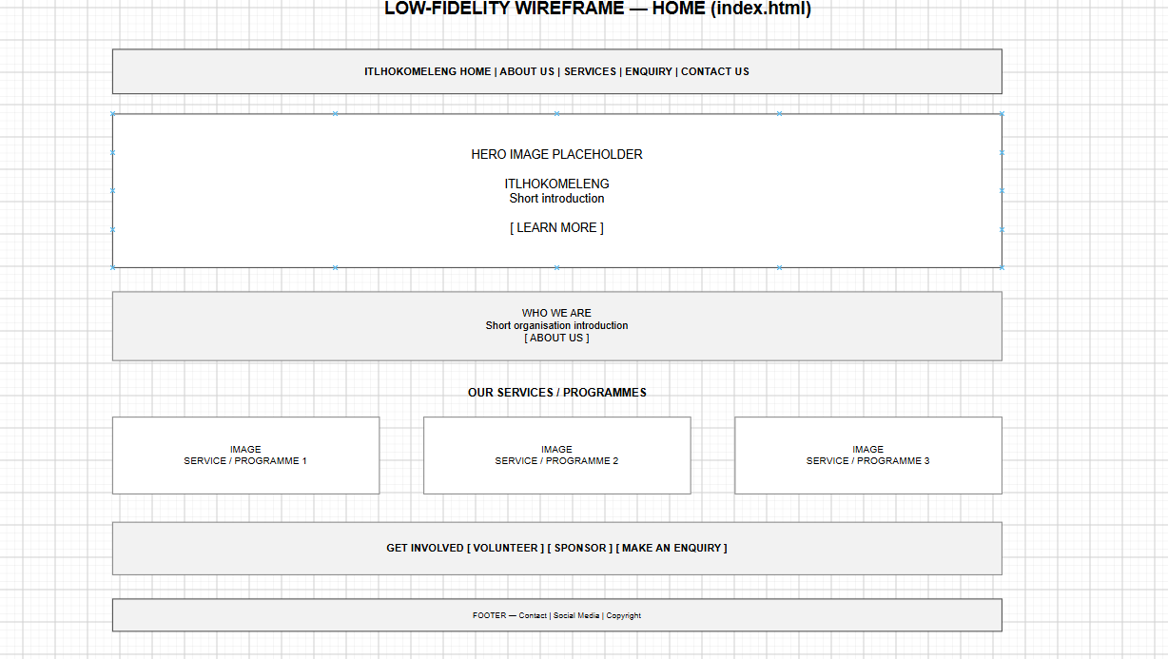
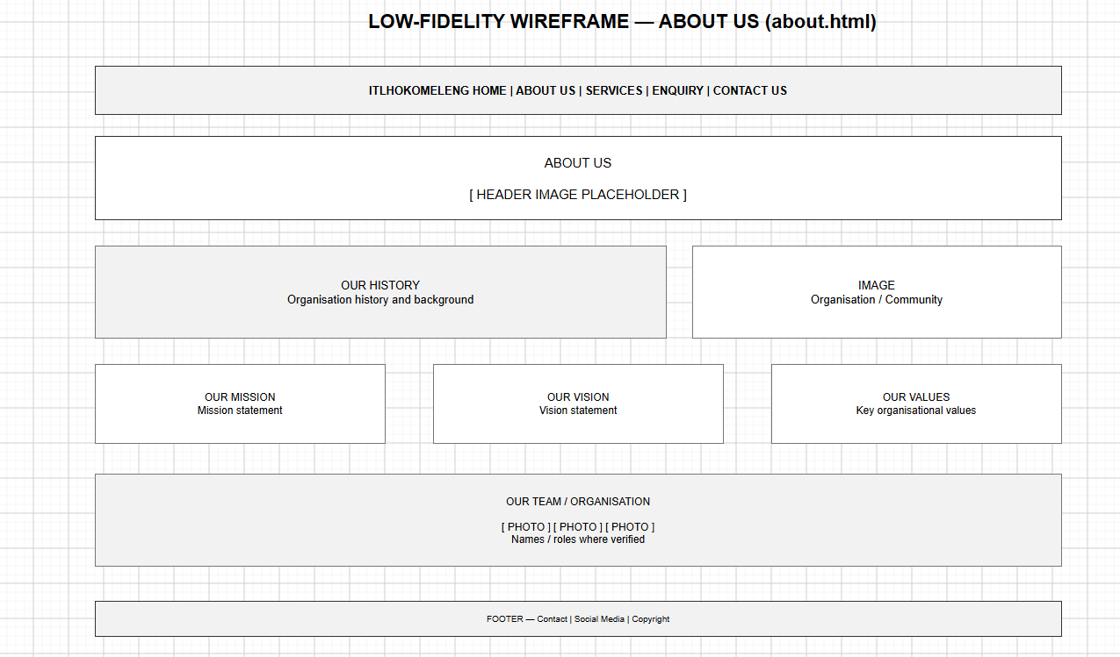

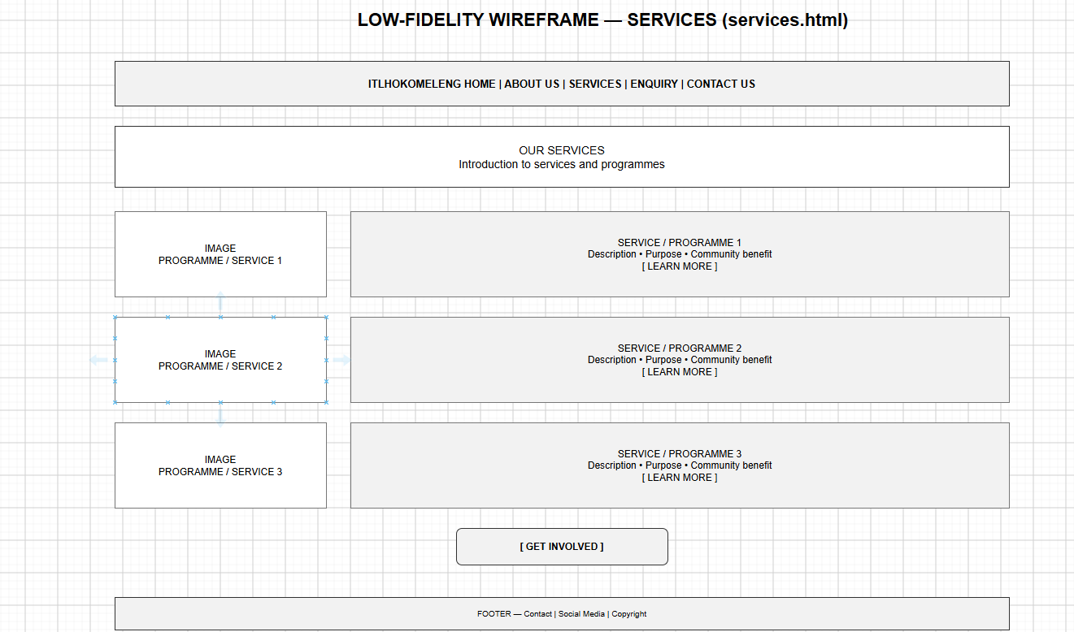

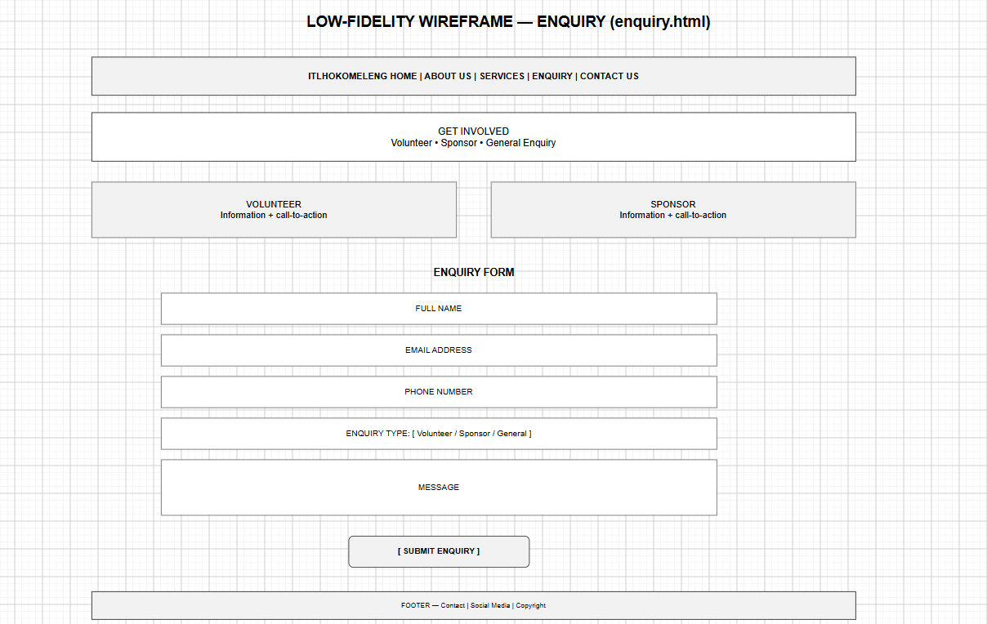

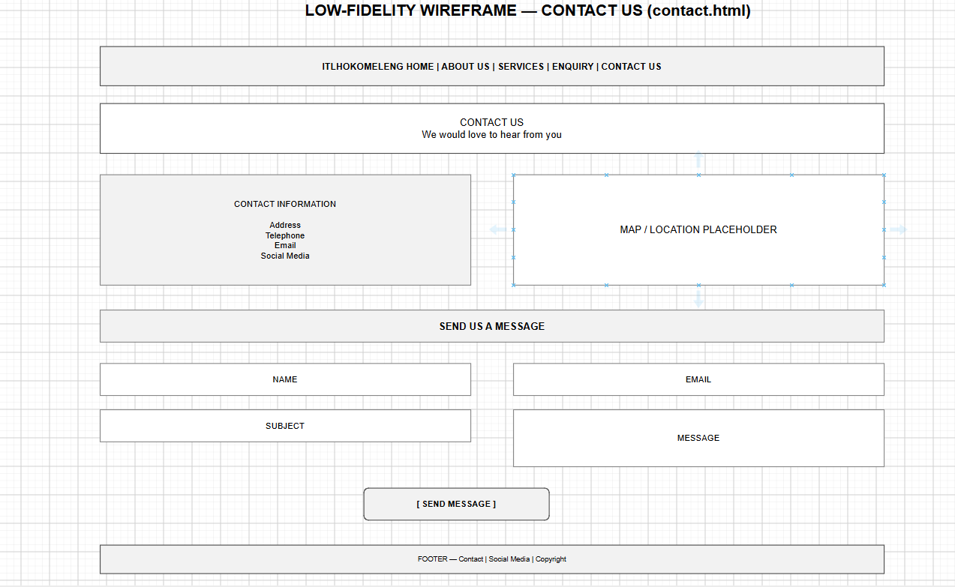

6. Technical Requirements
The website will be developed using standard web technologies.
6.1 Programming languages
- HTML5
- CSS3
- JavaScript
6.2 Development environment
The website will be developed using Visual Studio Code.
Website structure
Itlhokomeleng-Website/
│
├── index.html
├── about.html
├── services.html
├── enquiry.html
├── contact.html
├── README.md
│
├── css/
│ └── style.css
│
├── js/
│ └── script.js
│
└── images/

7. Timeline and Milestones
Week | Activity | Deliverable
Week 1 | Organisation research | Research notes
Week 1 | Website proposal | Approved proposal
Week 2 | Content research | Page content
Week 2 | Sitemap | Completed sitemap
Week 2 | Wireframes | Five low-fidelity wireframes
Week 3 | HTML development | Five HTML pages
Week 3 | CSS development | Website styling
Week 4 | JavaScript | Interactive functionality
Week 4 | Content and images | Completed website
Week 5 | Testing | Debugged website
Week 5 | GitHub | Repository updated
Week 5 | Documentation | README and evidence

8. Budget
If Itlhokomeleng decides to publish the website professionally, the organisation may later incur domain registration, hosting, maintenance and professional email costs.

9. Content Research and Sourcing
Content will be gathered from reliable sources.
Sources of information
Organisation information:
Available organisational information and direct communication with Itlhokomeleng will be prioritised.
News and public sources:
SABC News provides historical information about Itlhokomeleng, including its founding in 1978, location and services to vulnerable elderly and disabled people.
Alex News has also reported on the organisation's history and its relationship with community and charitable organisations.
Government/community sources:
The National Development Agency lists Itlokomeleng Association for the Aged among civil society organisations in Gauteng.
Images:
Images will be obtained from:
- Itlhokomeleng, with permission
- Original photographs, where permitted
- Unsplash
- Pexels
- Wikimedia Commons
- Other appropriately licensed Creative Commons sources
Images will be properly credited where required.

City of Johannesburg. 2025. Nelson Mandela Month Programme 2025. City of Johannesburg.
National Development Agency. (n.d.). Gauteng Civil Society Organisation Footprint. National Development Agency.
SABC News. 2012. 2012 SABC initiatives for Mandela Day. South African Broadcasting Corporation.
The Citizen. 2013. Company warms senior citizens with blankets. Alex News.
The Citizen. 2019. Elderly's home honours Gift of Givers. Alex News.
The Citizen. 2019. Old age home returns the favour. Alex News.
Good News Daily. 2020. Meet the “Mother Teresa of Alex”, running a care home at age 89.
Medpages. 2026. Itlhokomeleng Association for Aged & Disabled.
Prime News Africa. 2023. 702 Truck of Love lends a helping hand this festive season.

